**EXP NO 5** Create a simple cloud software application for Mark Sheet Processing System using any Cloud Service Provider to demonstrate SaaS include the necessary fields such as name of the student, Reg no of the student, Subjects, Marks, Average, percentage, rank, overall performance etc.

**PROCEDURE:**

**STEP 1:** GO TO THE ZOHO.COM

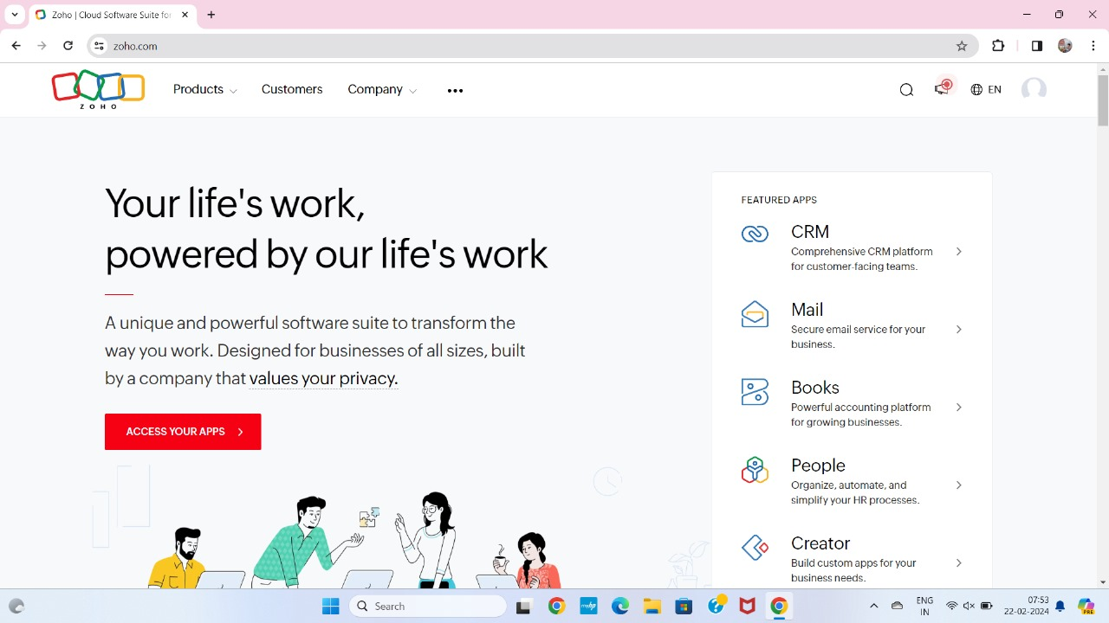

**STEP 2:** LOGIN THE ZOHO.COM

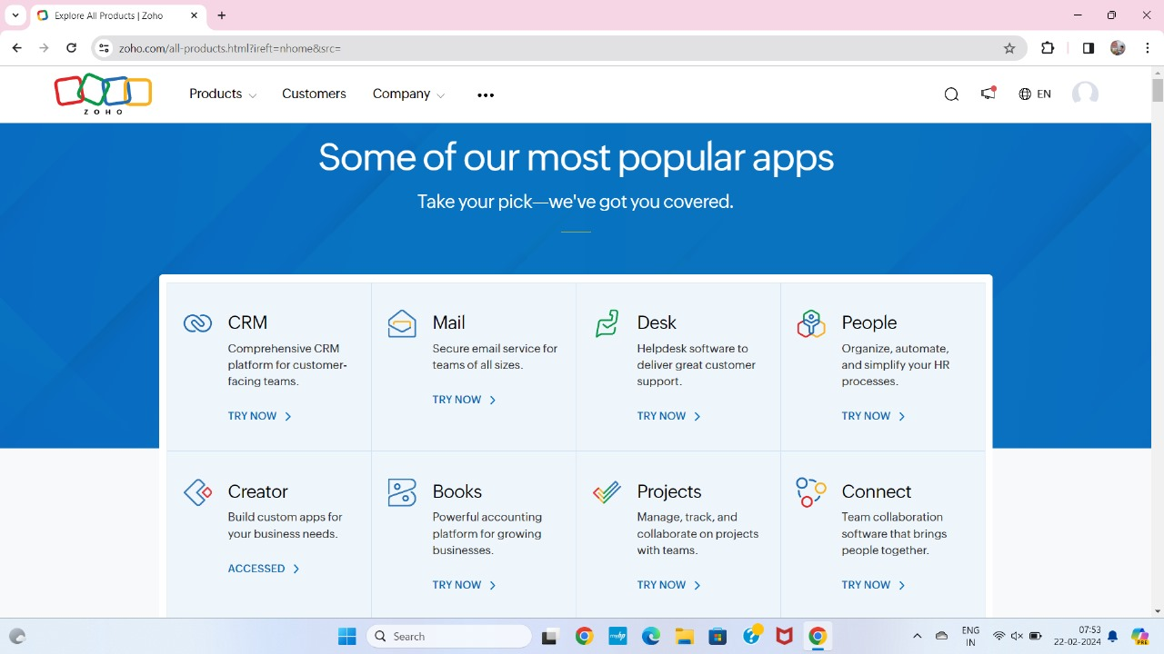

**STEP 3:** SELECT A CREATE FROM SCRATCH

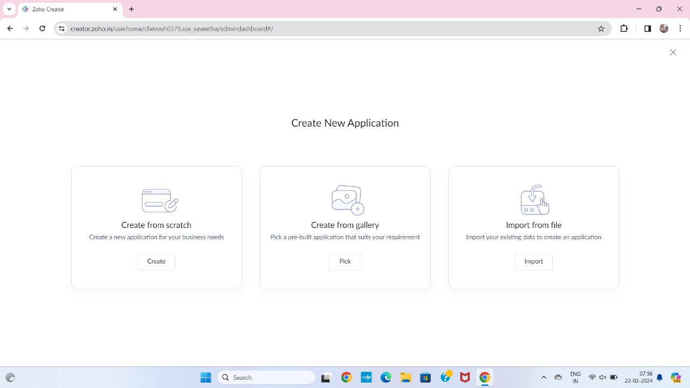

**STEP 4:** SELECT APPLICATION NAME AS MARK SHEET PROCESSING SYSTEM

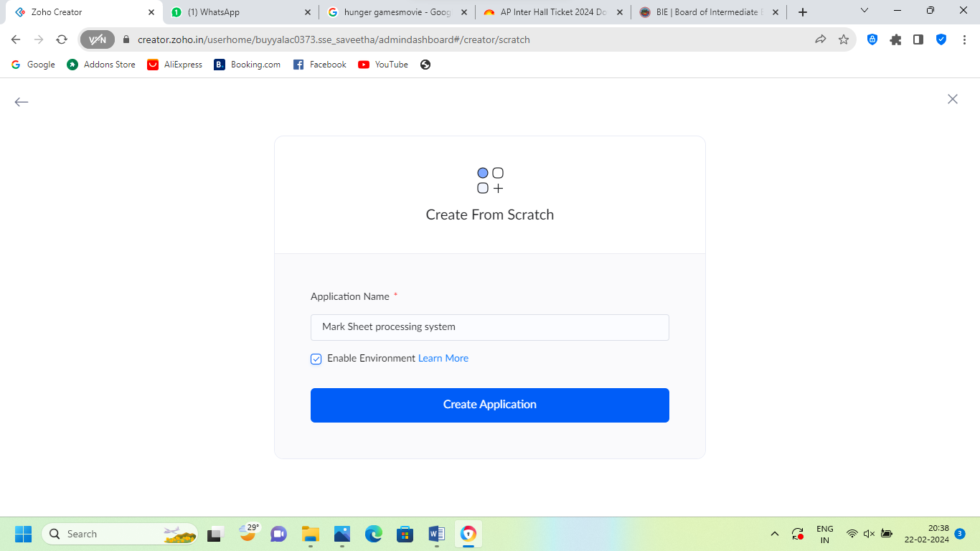

**STEP 5:** CREATE A NEW FORM

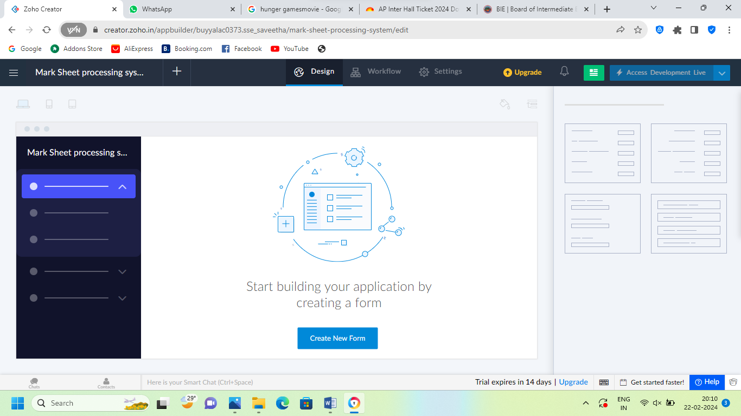

**STEP 6:** SELECT BASIC FIELD FROM GIVEN BELOW AND DEVELOP APPLICATION

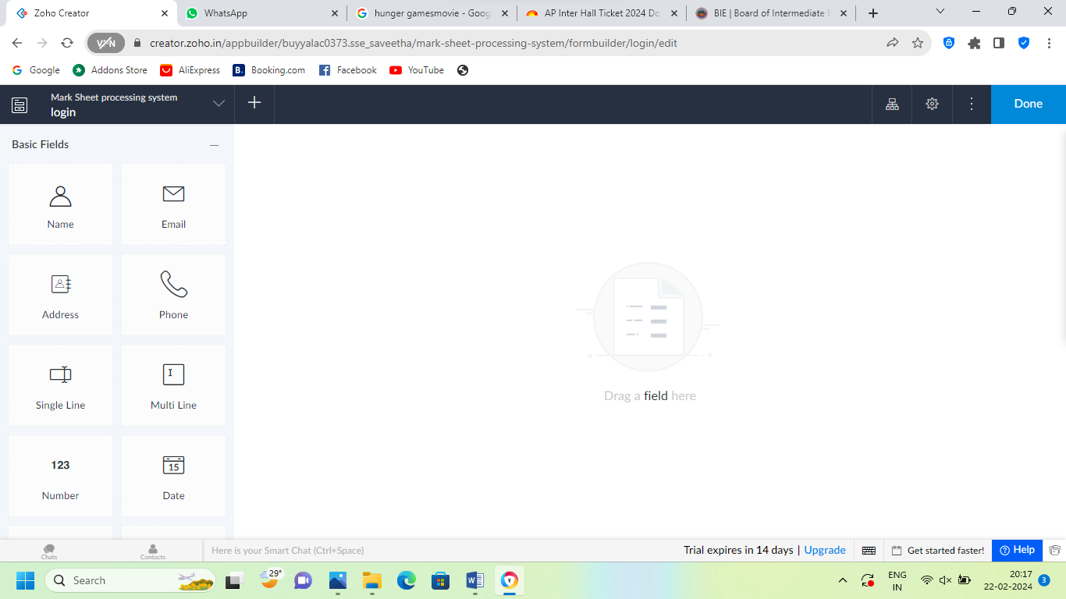

**STEP 7:** THE SOFTWARE HAS BEEN CREATED LOGIN PAGE

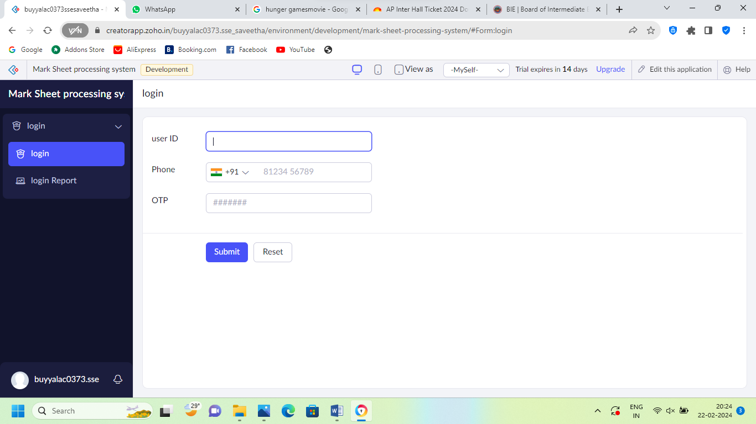

**STEP 8:** THE SOFTWARE HAS BEEN CREATED DETAILS OF THE STUDENT MARKS

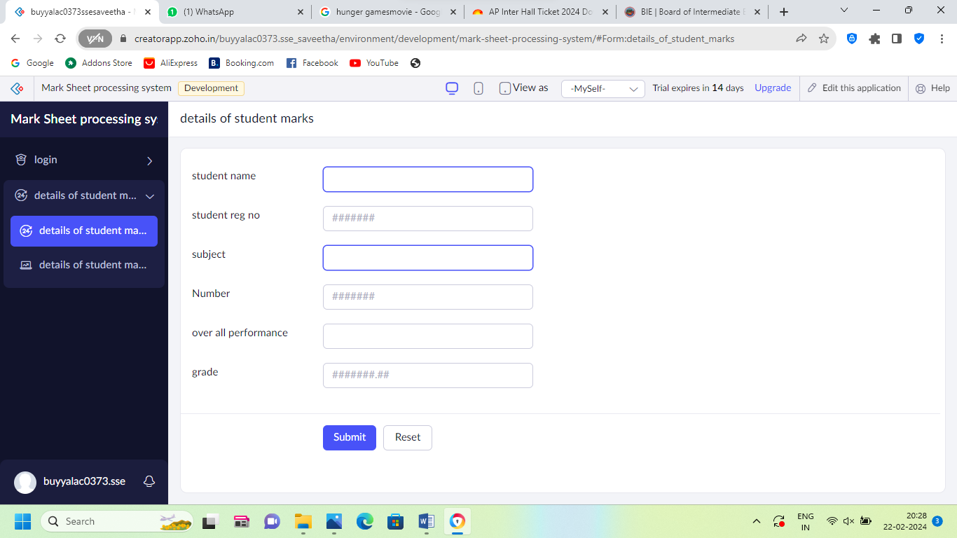

**STEP 9:** THE SOFTWARE HAS BEEN CREATED DISCUSSION WITH PARENTS

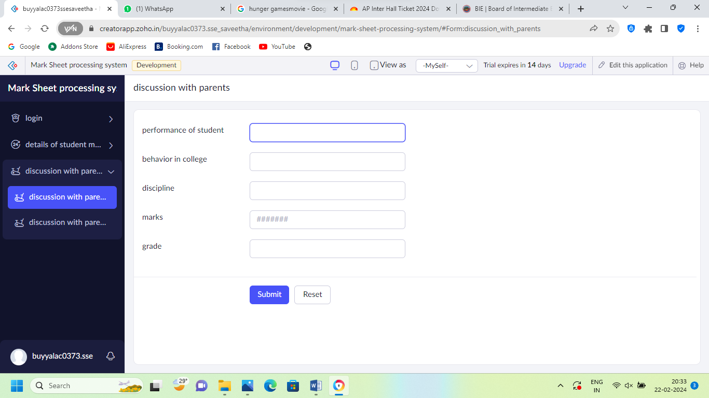

**STEP 10:** THE SOFTWARE HAS BEEN CREATED EXCEL

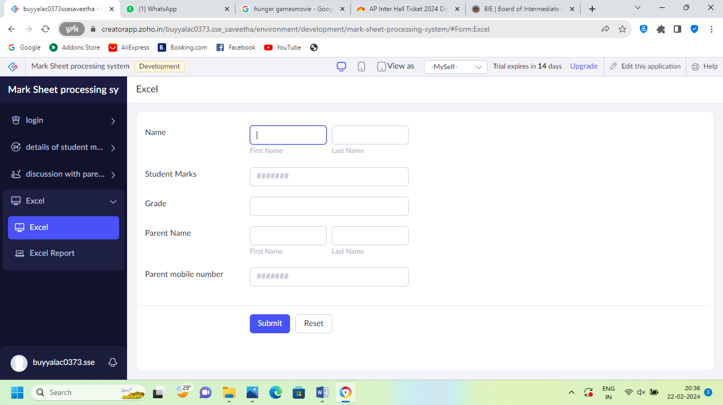

**STEP 11:** FINALLY THE SOFTWARE HAS BEEN CREATED

